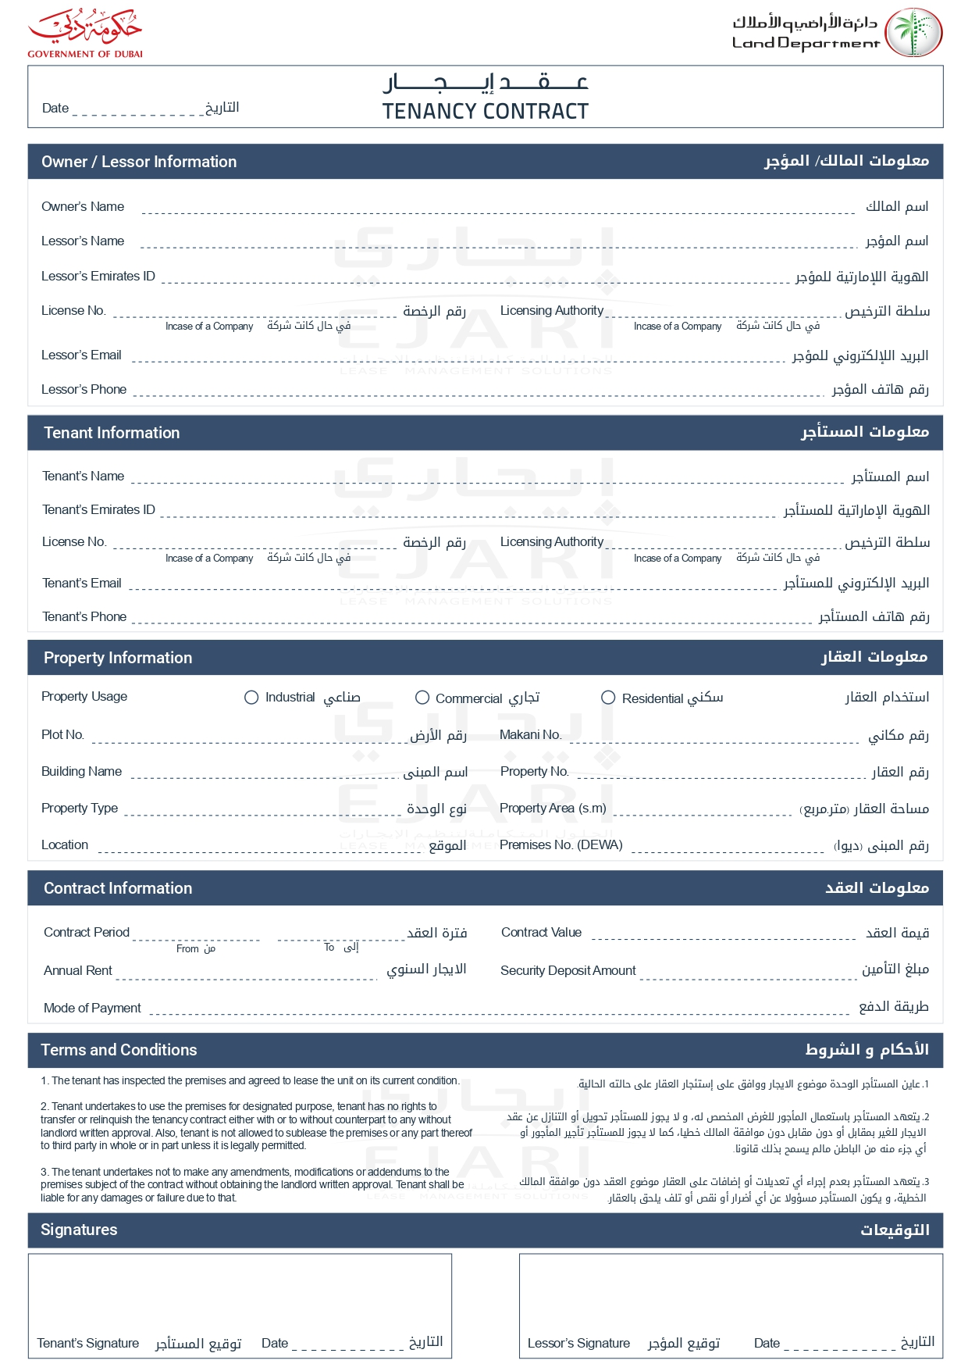

2025-04-09

John Smith

John Smith

john.smith@example.com

+971501234567

Mohammed Khan

mohammed.k@example.com

+971506789012

✓

G-201

Green Apartments

1,200.00

GA001

2,000.00 EGP

2025-08-09

2025-04-09

100.00 EGP

2,000.00 EGP

Weekly

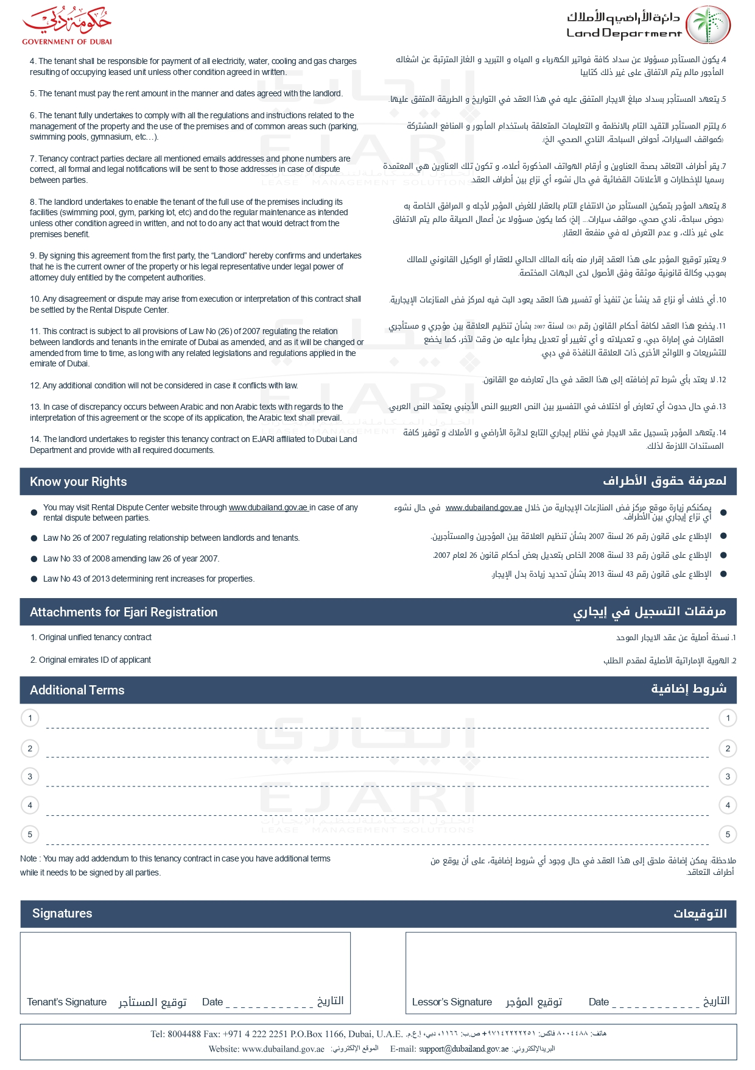

string terms 1